Formal Review Template
Requester Name: Jonathan Maronde
Reviewer Name: Mark Roberts
Date of Review: April 28 2026
Review Type (e.g., code, usability, design, other): code

Scope:
Artifact Reviewed:
sponsor_summary_service.rb, semesters_controller.rb, google_sheets_timesheet_parser_service.rb
Review Objectives:
Look at and evaluate deployed backend code and functionality

Methodology:
Approach Taken (e.g., execute, inspect, observe): Inspect and also observe
Evaluation Criteria (e.g., expected behavior, best practices, heuristic evaluation): does the backend work as intended and is code easy to read
Coverage / Limitations (e.g., test login only, ignore database integration): need a place to put the students time sheet

Findings
Strengths:
- Code has comments and looks readable
- The app now actually has the sentiment summary inside the site instead of on the rails CLI.
- Summary is actually correct and AI is a better version, while it does take a while to load.
- Also timesheet parser works correctly in the CLI.
Issues / Defects:
Description of Issue | Severity (Low/Med/High) | Evidence / Example | Suggested Fix
No place for students to put time sheet on the status page | medium | Nothing to show its not there | Add it
Leaving the page and coming back deletes the LLM summary | high | 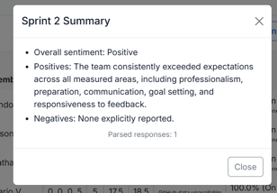 | Add some caching to make the response stay even on reload

